SOFTWARE QUALITY TESTING
FINAL EXAMINATION
Course: Manual Testing, API Testing,
JavaScript & Cypress Automation
Instructor: Joseph Adagba
Submitted By: Aghware Eguono Joshua
Project: API Testing Report
Date: July 2026

GET Request Testing

Endpoint
GET https://dummyjson.com/users

Validation Performed
- Status Code
- Response Time
- Headers
- JSON Structure

Result
Validation | Status
Status Code (200 OK) | Pass
Response Time | Pass
Headers | Pass
JSON Structure | Pass
Screenshot
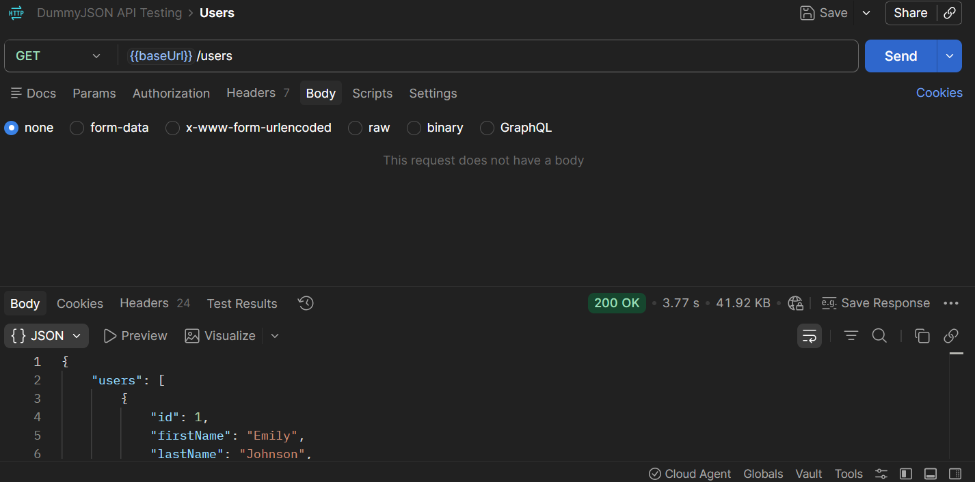

POST Request Testing

Endpoint
POST https://dummyjson.com/users/add

Validation Performed
- Response
- Status Code
- Response Body

Result
Validation | Status
Response | Pass
Status Code | Pass
Response Body | Pass
Screenshot
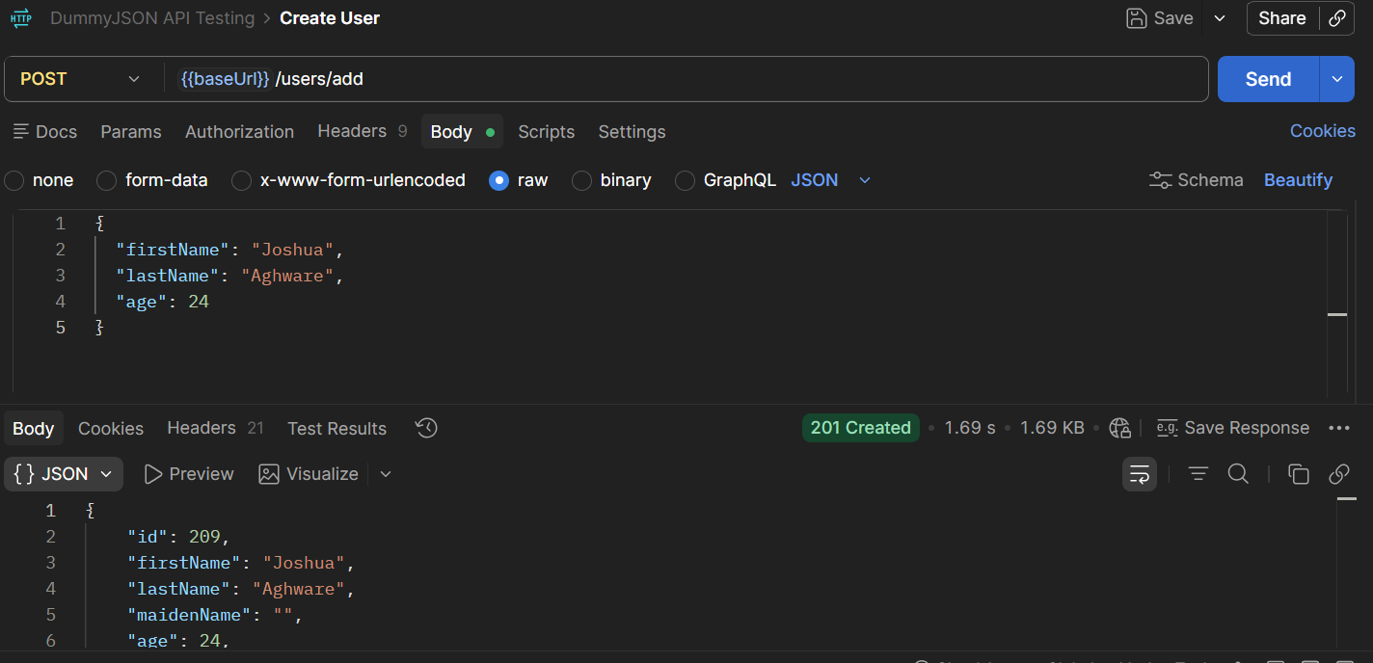

DELETE Request Testing

Endpoint
DELETE https://dummyjson.com/users/1

Validation Performed
- Status Code
- Response Message

Result
Validation | Status
Status Code | Pass
Response Message | Pass
Screenshot
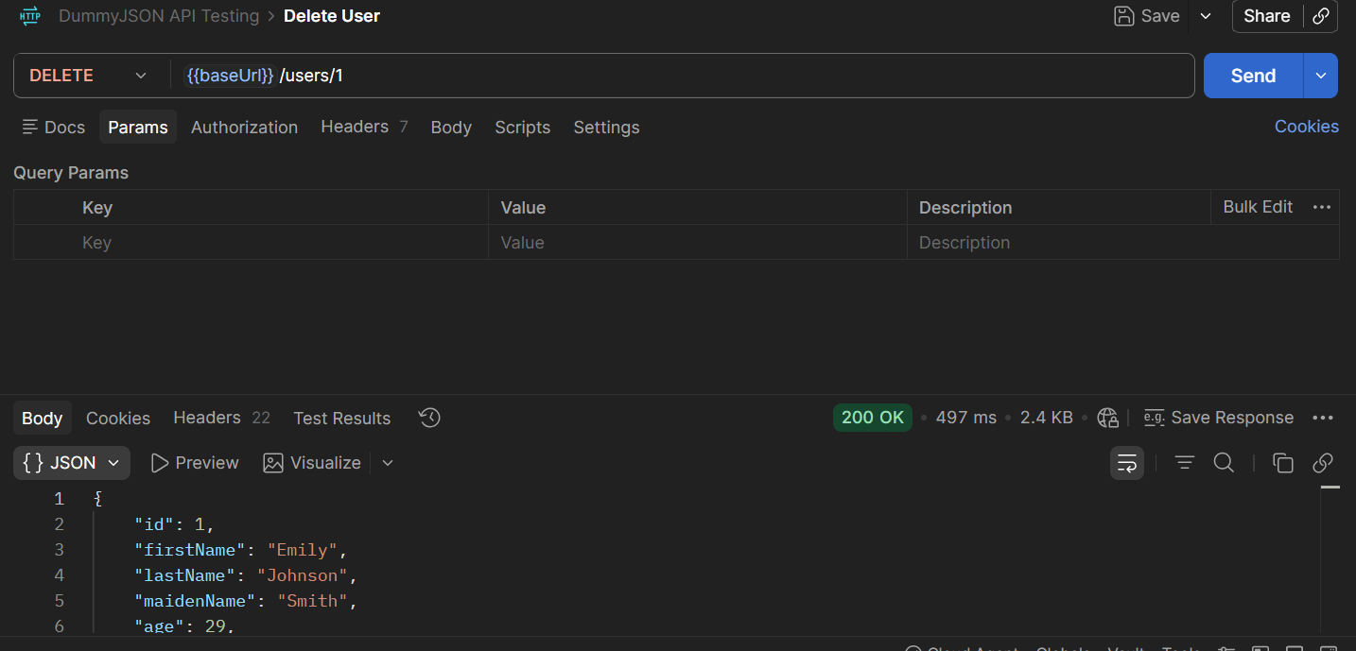

Conclusion
The DummyJSON API was tested using Postman. All three endpoints (GET, POST, and DELETE) responded successfully, and the required validations for status codes, response body, response time, headers, and JSON structure were completed successfully. The API behaved as expected during testing.

